Practical #02: Composition in Java classes

**2.1 An Introduction to OOP Composition by Example - the Author and Book Classes**

This first exercise shall lead you through all the concepts involved in OOP Composition.

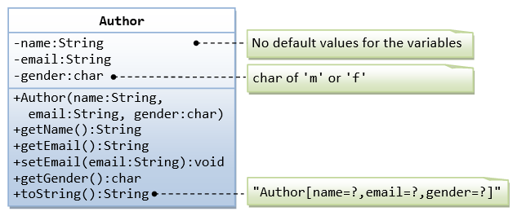

A class called Author (as shown in the class diagram) is designed to model a book's author. It contains:

* Three private instance variables: name (String), email (String), and gender (char of either 'm' or 'f');
* One constructor to initialize the name, email and gender with the given values.

public Author (String name, String email, char gender) {......}

(There is no default constructor for Author, as there are no defaults for name, email and gender.)

* public getters/setters: getName(), getEmail(), setEmail(), and getGender();  
  (There are no setters for name and gender, as these attributes cannot be changed.)
* A toString() method that returns "Author[name=?,email=?,gender=?]", e.g., "Author[name=Ketaki Ghawali,email=ketaki@vsit.edu.in,gender=f]".

**Write the Author class. Also write a *test driver* called TestAuthor to test all the public methods, e.g.,**

Author at = new Author("Ketaki Ghawali", "ketaki@vsit.edu.in", 'f'); // Test the constructor

System.out.println(at); // Test toString()

at.setEmail("paulTan@nowhere.com"); // Test setter

System.out.println("name is: " + at.getName()); // Test getter

System.out.println("eamil is: " + at.getEmail()); // Test getter

System.out.println("gender is: " + at.getGender()); // Test getter

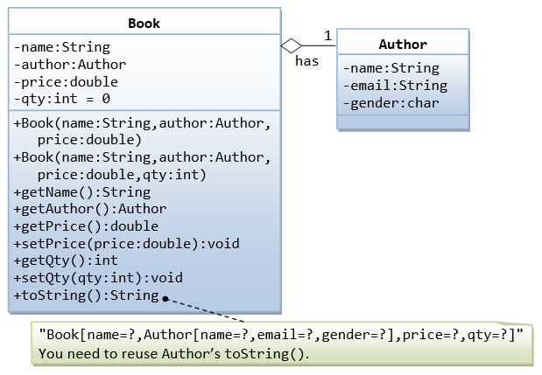

A class called Book is designed (as shown in the class diagram) to model a book written by *one* author. It contains:

* Four private instance variables: name (String), author (of the class Author you have just created, assume that a book has one and only one author), price (double), and qty (int);
* Two constructors:
* public Book (String name, Author author, double price) { ...... }

public Book (String name, Author author, double price, int qty) { ...... }

* public methods getName(), getAuthor(), getPrice(), setPrice(), getQty(), setQty().
* A toString() that returns "Book[name=?,Author[name=?,email=?,gender=?],price=?,qty=?".  You should reuse Author’s toString().

Write the Book class (which uses the Author class written earlier). Also write a test driver called TestBook to test all the public methods in the class Book. Take Note that you have to construct an instance of Author before you can construct an instance of Book. E.g.,

// Construct an author instance

Author at = new Author("Ketaki Ghawali", "ketaki@vsit.edu.in", 'f');

System.out.println(at); // Author's toString()

Book dummyBook = new Book("Java for dummy", at, 19.95, 99); // Test Book's Constructor

System.out.println(dummyBook); // Test Book's toString()

// Test Getters and Setters

dummyBook.setPrice(29.95);

dummyBook.setQty(28);

System.out.println("name is: " + dummyBook.getName());

System.out.println("price is: " + dummyBook.getPrice());

System.out.println("qty is: " + dummyBook.getQty());

System.out.println("Author is: " + dummyBook.getAuthor()); // Author's toString()

System.out.println("Author's name is: " + dummyBook.getAuthor().getName());

System.out.println("Author's email is: " + dummyBook.getAuthor().getEmail());

// Use an anonymous instance of Author to construct a Book instance

Book anotherBook = new Book("more Java",

new Author("Ketaki Ghawali", "ketaki@vsit.edu.in", 'f'), 29.95);

System.out.println(anotherBook); // toString()

Take note that both Book and Author classes have a variable called name. However, it can be differentiated via the referencing instance. For a Book instance says aBook, aBook.name refers to the name of the book; whereas for an Author's instance say auAuthor, anAuthor.name refers to the name of the author. There is no need (and not recommended) to call the variables bookName and authorName.

TRY:

1. Printing the name and email of the author from a Book instance. (Hint: aBook.getAuthor().getName(), aBook.getAuthor().getEmail()).
2. Introduce new methods called getAuthorName(), getAuthorEmail(), getAuthorGender() in the Book class to return the name, email and gender of the author of the book. For example,
3. public String getAuthorName() {

return author.getName(); // cannot use author.name as name is private in Author class

}

Your CODE:

package prac_04;

public class Author_01 {

private String name;

private String email;

private char gender;

public Author_01(String name, String email, char gender) {

this.name = name;

this.email = email;

this.gender = gender;

}

public String getName() {

return name;

}

public void setName(String name) {

this.name = name;

}

public String getEmail() {

return email;

}

public void setEmail(String email) {

this.email = email;

}

public char getGender() {

return gender;

}

public void setGender(char gender) {

this.gender = gender;

}

@Override

public String toString(){

return "Author_01 {" + "name = " + name +"Email = " + email + " Gender = " + gender +"}";

}

}

package prac_04;

public class Prac_04 {

public static void main(String[] args) {

Author_01 a1=new Author_01("kavish","kavish@vsit.edu.in",'m');

System.out.println(a1);

a1.setEmail("Bruce55@gmail.com");

System.out.println(a1);

System.out.println("Name : " + a1.getName());

System.out.println("Email : " + a1.getEmail());

System.out.println("Gender : " + a1.getGender());

}

}

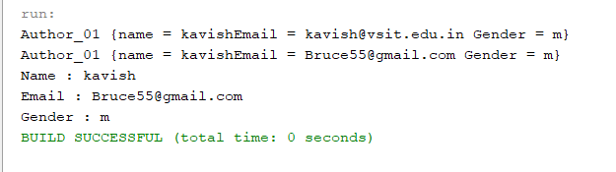

package prac_04;

public class Book {

private String name;

private Author_01 author;

private double price;

private int qty=0;

public Book(String name, Author_01 author, double price){

this.name = name;

this.author = author;

this.price = price;

}

public Book(String name, Author_01 author, double price,int qty){

this.name = name;

this.author = author;

this.price = price;

this.qty = qty;

}

public String getName() {

return name;

}

public Author_01 getAuthor_01() {

return author;

}

public double getPrice() {

return price;

}

public int getQty() {

return qty;

}

public void setPrice(double price) {

this.price = price;

}

public void setQty(int price) {

this.qty = qty;

}

@Override

public String toString() {

return "Book{" + "name=" + name + ", author=" + author + ", price=" + price + ", qty=" + qty + '}';

}

}

package prac_04;

public class Prac_04 {

public static void main(String[] args) {

Author_01 a1=new Author_01("kavish","kavish@vsit.edu.in",'m');

System.out.println(a1);

Book b1=new Book("Bruce",a1,69.33,55);

System.out.println(b1);

b1.setPrice(75.35);

b1.setQty(22);

System.out.println("Name : " + b1.getName());

System.out.println("Price : " + b1.getPrice());

System.out.println("Author : " + b1.getAuthor_01());

System.out.println("Qty : " + b1.getQty());

Book b2 = new Book("Kaavish",

new Author_01("imdone","imdone@gmail.com",'m'),78.55);

System.out.println(b2);

}

}

